HOMEPAGE DASHBOARD
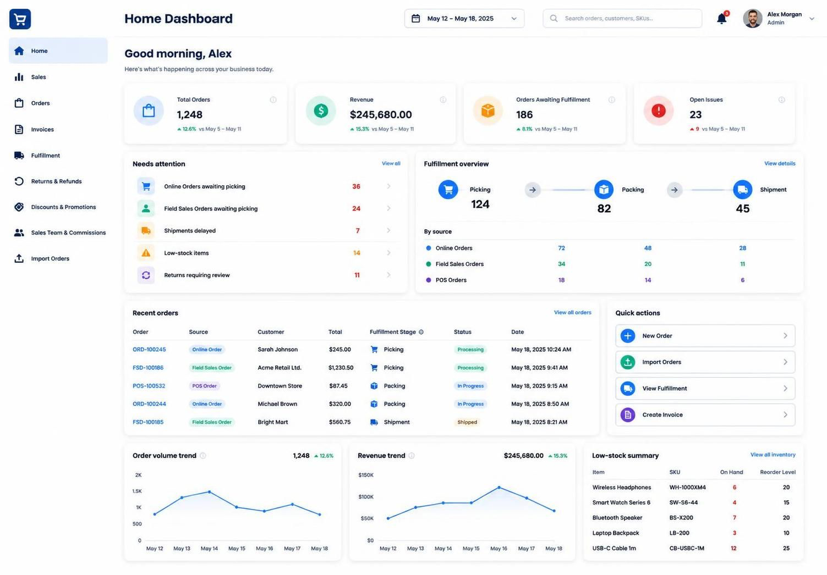
Currently Sales Dashboard and Homepage dashboards are the same. We need the homepage dashboard to be different. Follow this:

INVENTORY

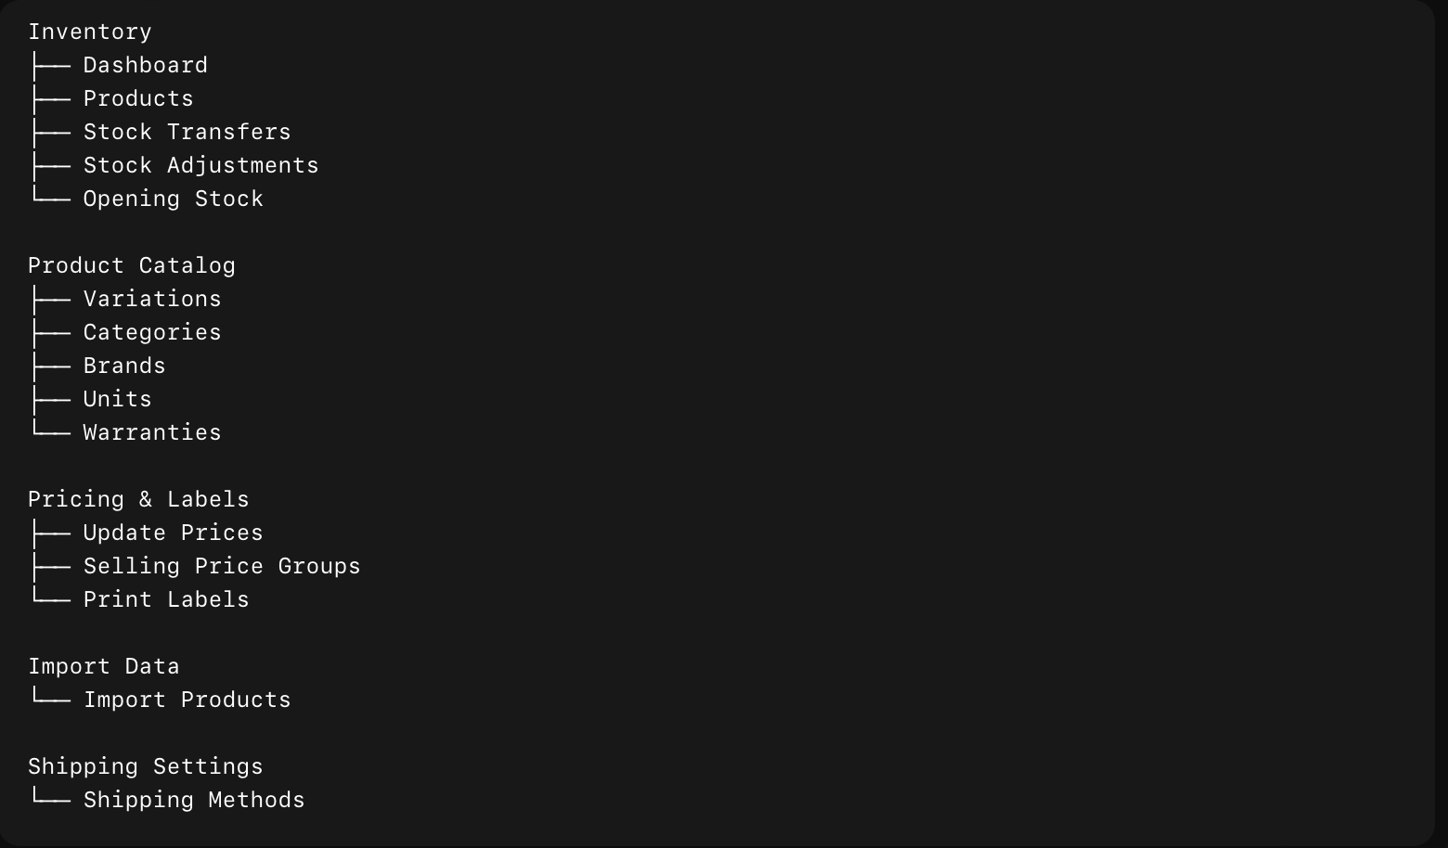

SALES

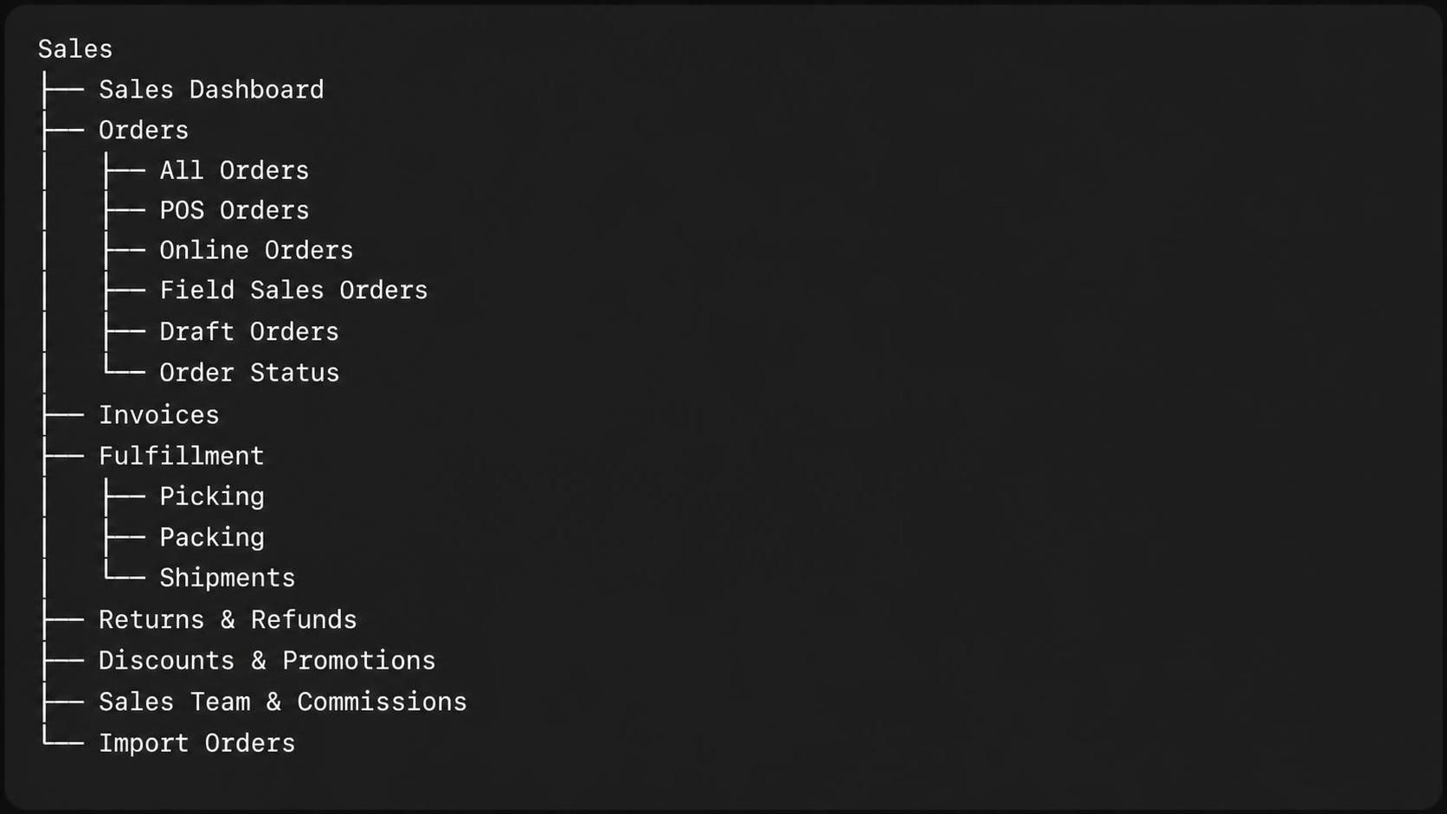

Any order placed through Online Orders or Field Sales Orders automatically enters the Fulfillment pipeline at the Picking stage — no manual routing needed."
Source tagging requirement:
"Every order that enters Fulfillment must retain a visible source tag indicating whether it came from Online Orders or Field Sales Orders. This tag should be:
- Stored on the order record itself (e.g., an order_source field), not just inferred
- Displayed on the Fulfillment views (Picking, Packing, Shipment) as a badge or label next to each order
- Filterable — staff should be able to filter the Fulfillment queue by source (e.g., view only Online Orders awaiting picking)"
Stage-by-stage flow:
- Picking — Order lands here first, tagged with its source. Warehouse staff picks the items and marks it ready.
- Packing — Once picked, order advances to Packing, source tag still visible.
- Shipment — Once packed, order moves to Shipment. This is the final stage — order is complete once shipped.
Picking Page:
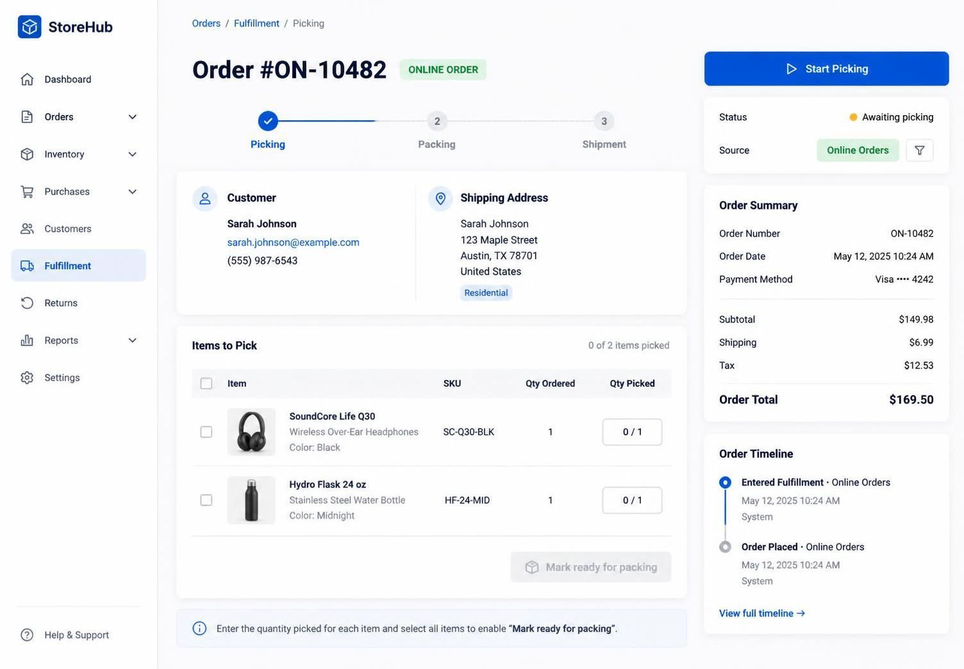

Packing Page:
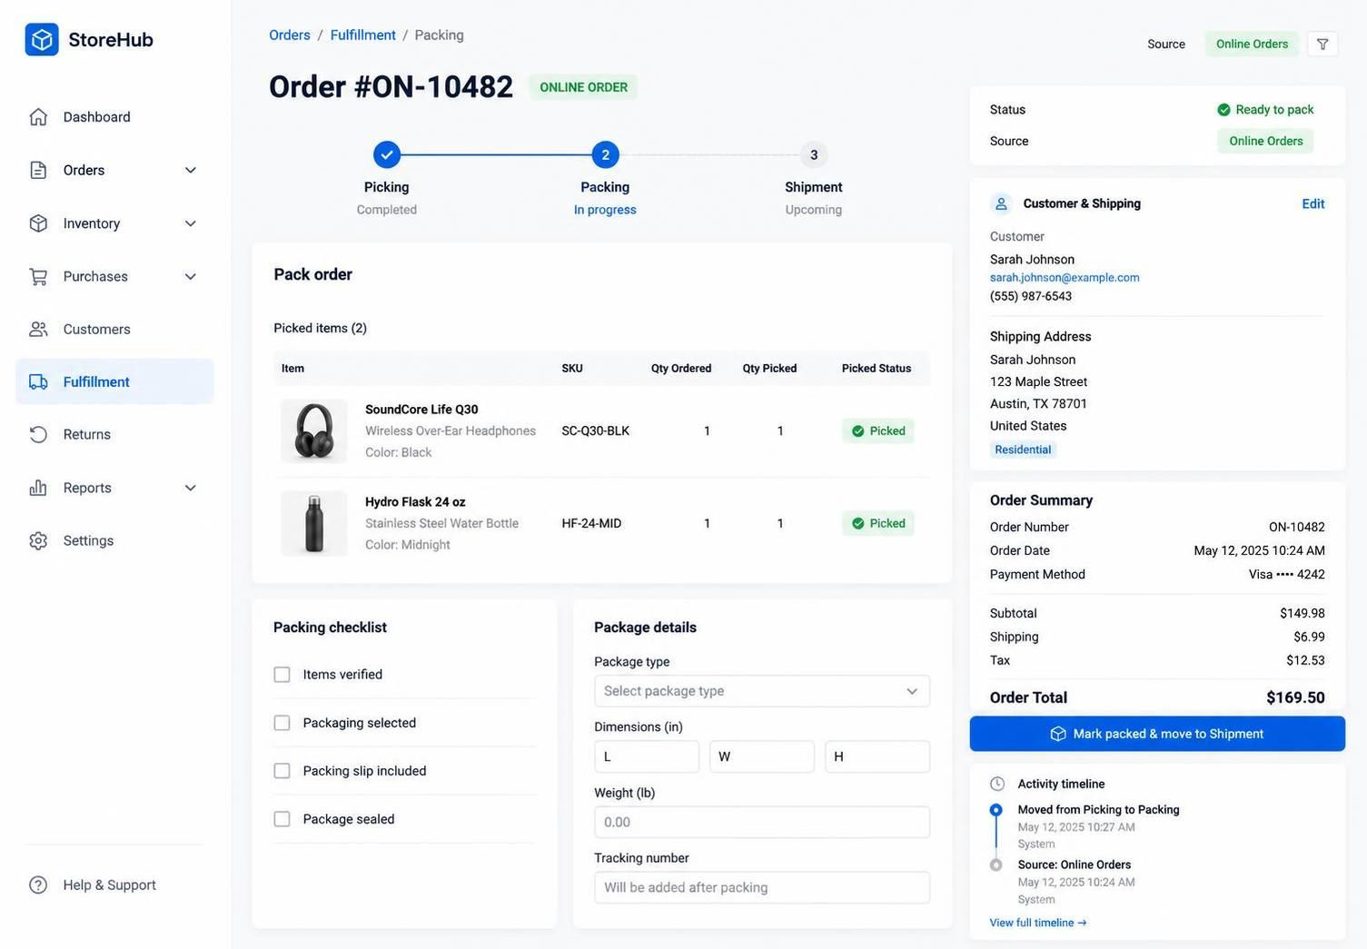

Shipment Page:
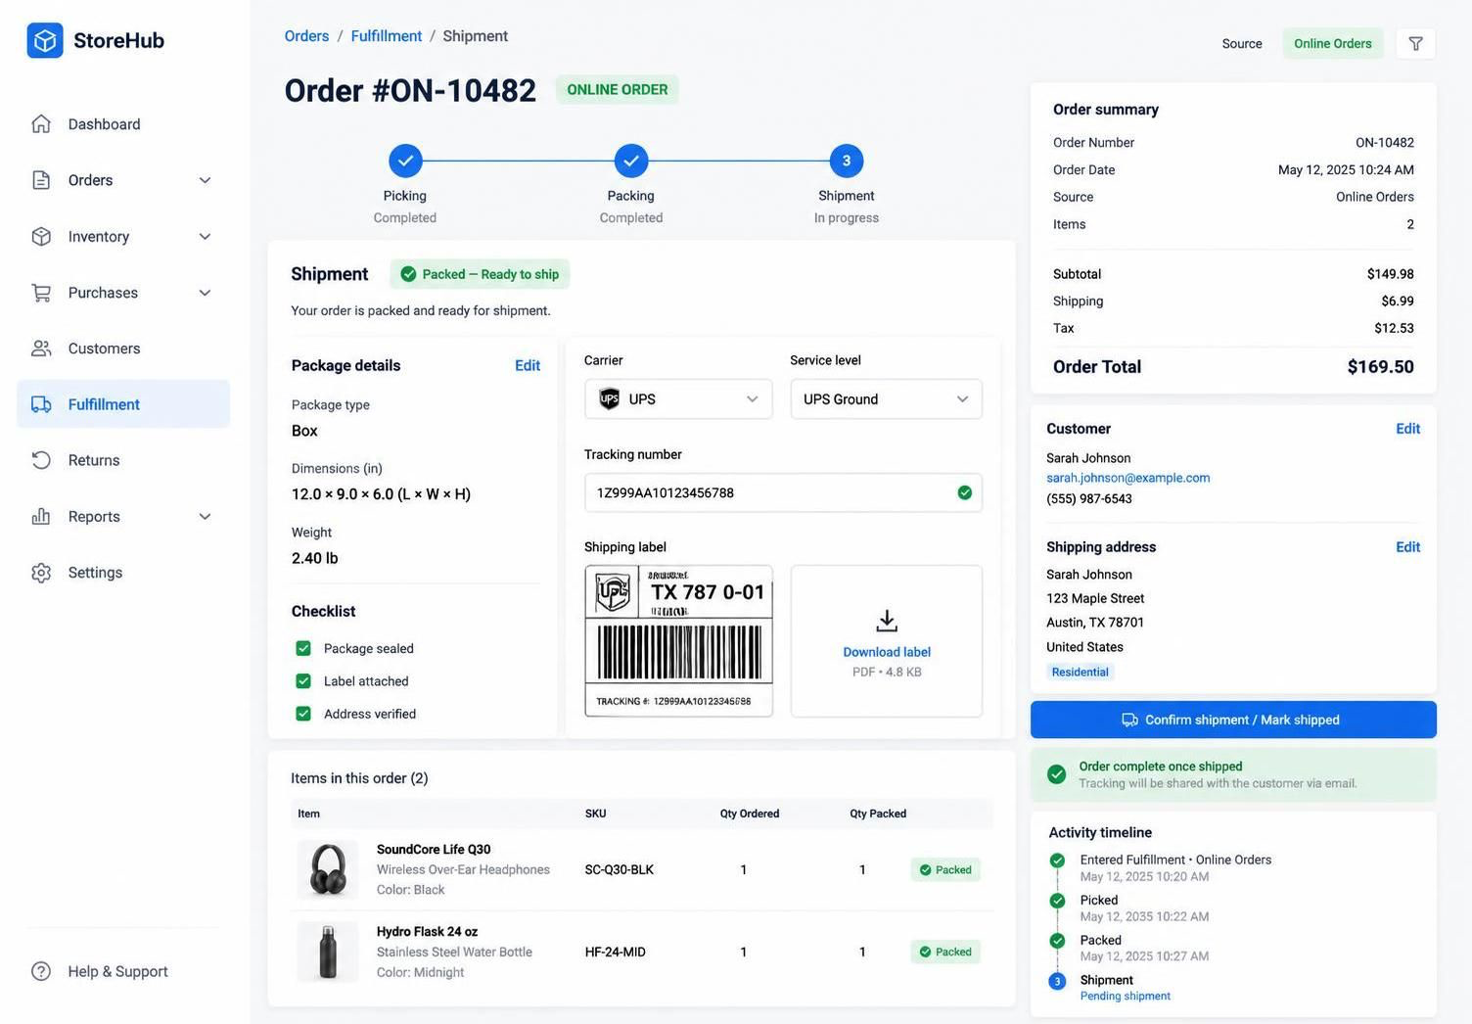
CRM

- Dashboard
- Customer
  - Customer
  - Customer Groups
- Leads
  - Leads
  - Pipeline
  - Follow Ups
  - Call Log
- Settings

REPORTS
- Business Overview
  - Profit & Loss
  - Cash Flow
  - Expense Report
  - Register Report
- Sales
  - Sales Summary
  - Sales by Customer
  - Sales by Product
  - Sales Representative
  - Customer Groups
- Purchasing
  - Purchase Summary
  - Purchases by Product
  - Purchase Payments
  - Suppliers
- Inventory
  - Stock Report
  - Stock Adjustment
  - Inventory Valuation
  - Items Report
  - Trending Products
- Customers & Suppliers
  - Customer Report
  - Supplier Report
  - Customer Groups
- Taxes & Compliance
  - Tax Report
  - MSA Tobacco Report
- Employees & Activity
  - Time Clock
  - Sales Representatives
  - Activity Log

Everything above is completed. Except Reports. I have yet to evaluate it.

New Requirements- (09/03/2026)

The following requirement is for Prime Plus. But we can apply it to everyone because these are some good pointers:

- Supplier name is in the Brand
  - This is how it is right now. Its wrong (Prime Plus)

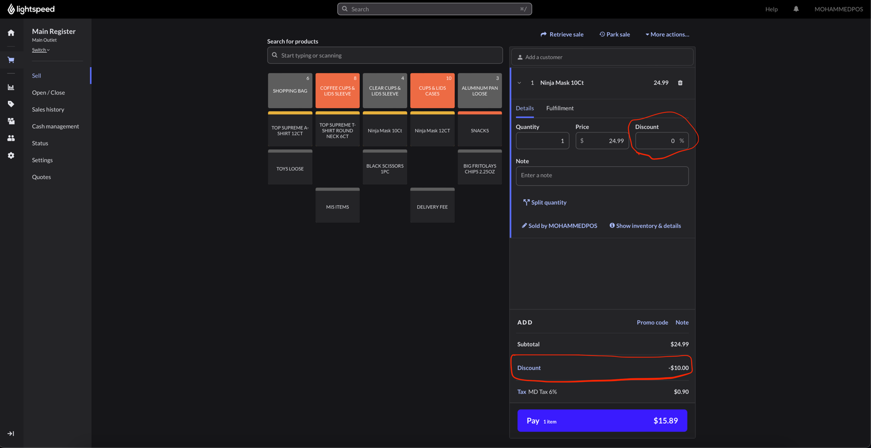
- We want to show discount to apply in the invoices and POS

  - In our one we have the discount. But its not showing up.

- Add stock in “Add New Product”
  - Yes, we have the option to add stock once we click on “Save & Add Opening Stock” But Prime Plus requested if we can have a box where we add the stock so they don’t need to go to click on anything else. They can do it smoothly in one page.

- Feature: Unit-of-Measure (UoM) Conversion & Pricing
Problem: Right now, "Unit" (Box/Pcs) and "Quantity" are treated as flat fields. We need the system to understand the relationship between units — how many pieces are in a box — so it can price and sell at either level.
Example:
- Product: KitKat
- Base unit: Pcs
- Packaging unit: Box
- Conversion: 1 Box = 10 Pcs
- Box price: $10.00 → system should auto-calculate Pcs price: $1.00 (or allow manual override)
- At checkout: selling 1 Box = $10.00, selling 1 Pcs = $1.00, selling 3 Pcs = $3.00
What needs to change on "Add New Product":
- Base Unit field — the smallest sellable unit (e.g., Pcs). This is what stock is tracked in internally.
- Purchase/Packaging Unit field — the bulk unit (e.g., Box, Case, Carton).
- Conversion Factor field — numeric input: "1 [Packaging Unit] = ___ [Base Unit]" (e.g., 1 Box = 10 Pcs).
- Price per unit — allow entering price at either level:
      - Enter Box price → system auto-computes Pcs price (Box price ÷ conversion factor)
  - Or enter Pcs price → system auto-computes Box price (Pcs price × conversion factor)
  - Should allow manual override in case bulk pricing isn't a clean multiple (e.g., box discount).
What needs to change at checkout/POS screen:
- Cashier selects the product, then selects which unit they're selling in (Box or Pcs) via a toggle/dropdown.
- System pulls the correct price for that unit automatically.
- Inventory deduction must happen in base units — selling 1 Box deducts 10 Pcs from stock, selling 3 Pcs deducts 3 Pcs from stock. This keeps one source of truth for stock count regardless of which unit was sold.
Sales App: (Ask me for login information for OIS Pro tomorrow)
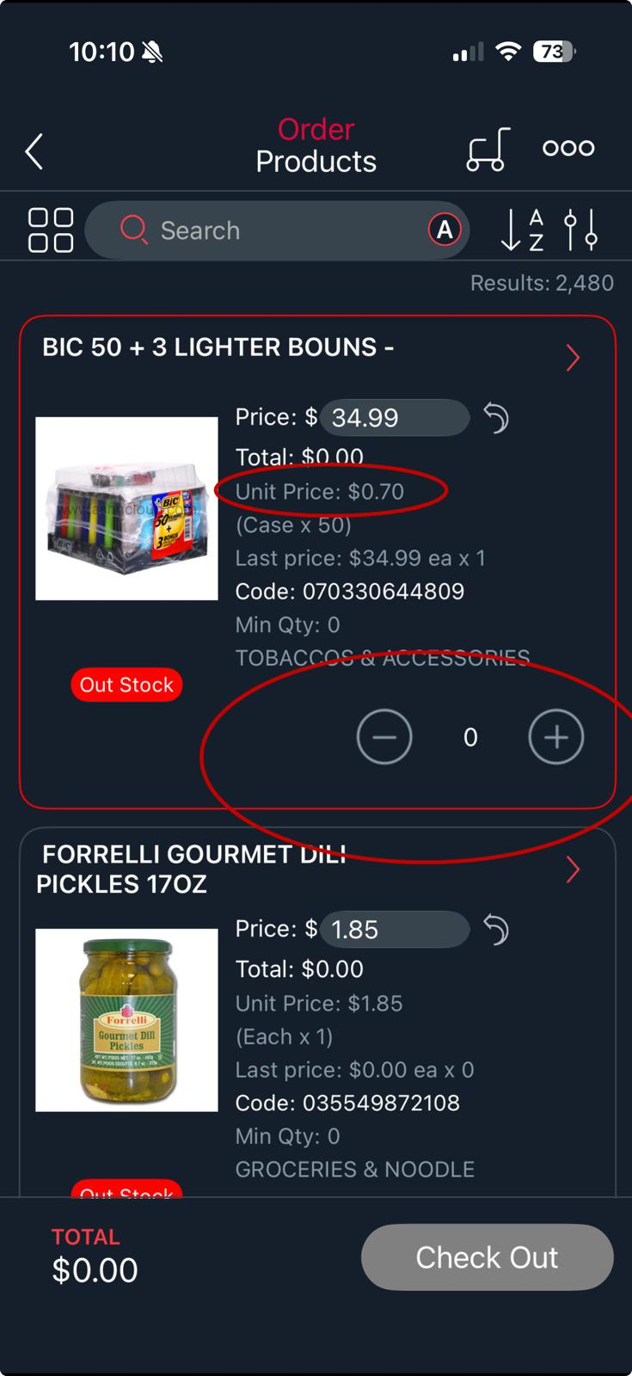

- POS Screen quick access (Prime Plus)
  - In POS Screen quick access we want to be able to customize it just like how it is in lightspeed.
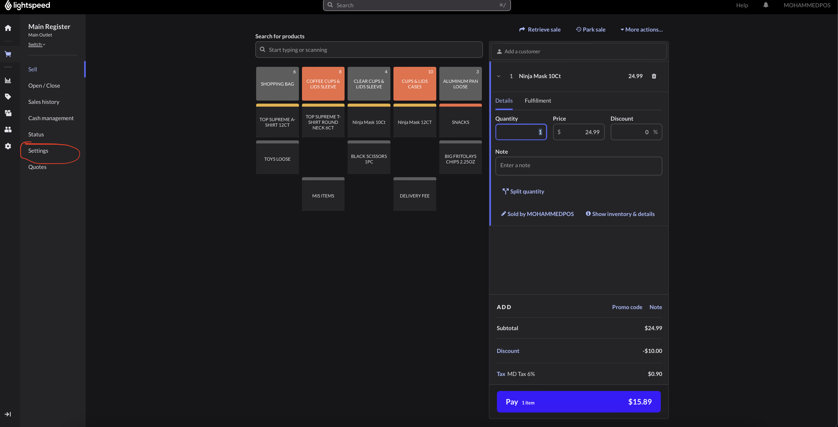
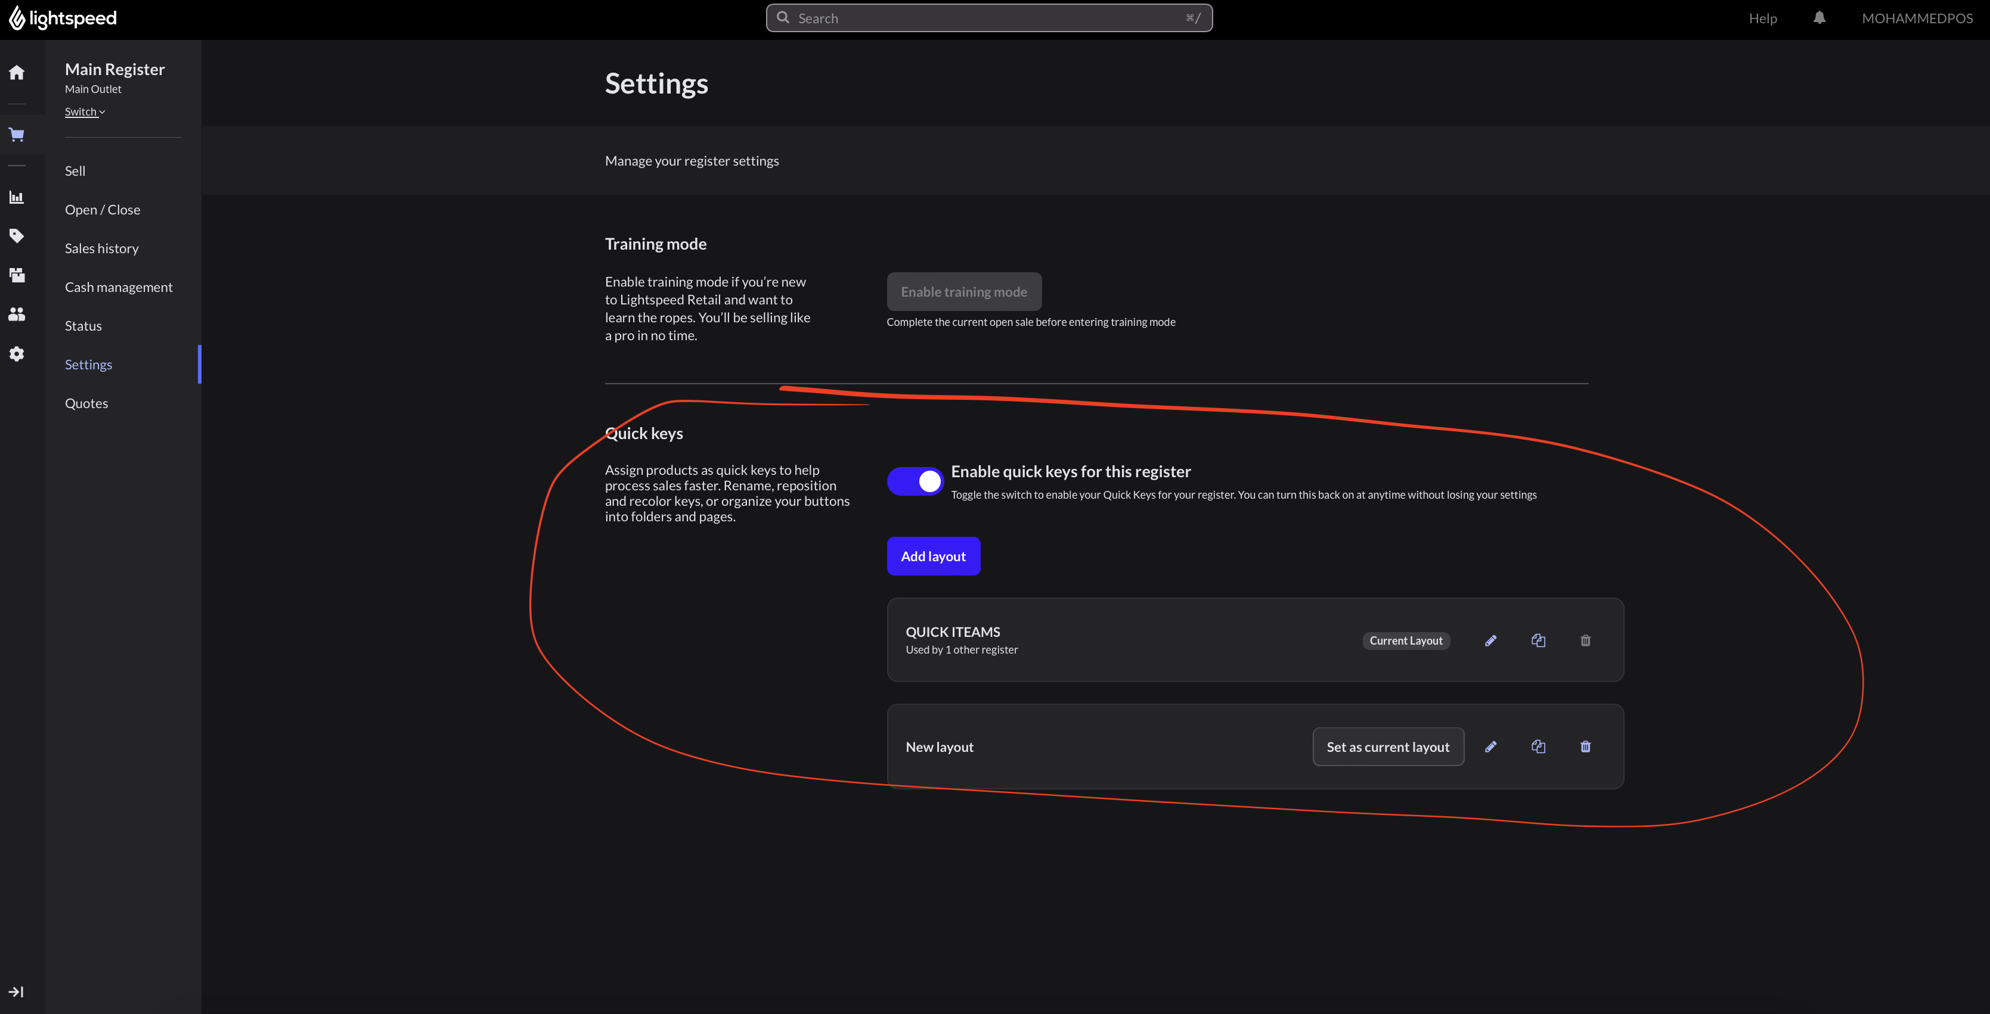
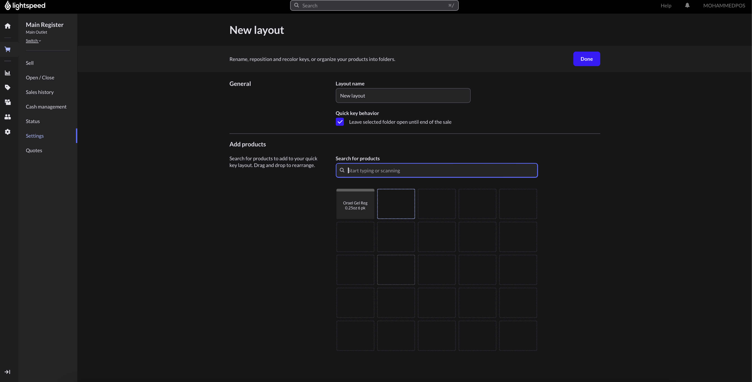
- Each user is able to customize their quick access.

- Main Setting
  - User
    - Make it same as LightSpeed



